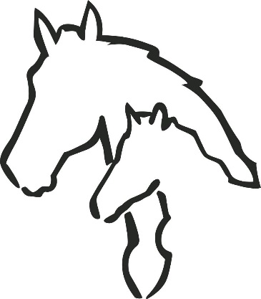

BLF
Bonnie Lea Farm AEL
Invites You
to a North East AEL Competition Saturday, April 20, 2019 In Williamstown, MA

Date: Saturday, April 20, 2019
Judge: Leslie Ernst Steward: TBD Practicum Phase: #6
Fence Test: #2

Available at www.athleticequestrian.com
Schedule of Events

8:30 am: Schooling of Horses
9:30 am: Coaches meeting and Draw 10:00 am: Competition Begins
Divisions will include, Open, Intermediate, Novice, Advanced Beginner, Beginner, Minis and Adult

The Bonnie Lea Farm Equestrian Team AEL competition will run according to the rules and regulations of the AEL.

Entry Fee: $60/Rider payable to Bonnie Lea Farm

Organizer/Manager: Lisa DeMayo, demayolisa@gmail.com - 413-441-6349

Entry Deadline: Entries are due to Competition Organizer by Monday, April 8, 2019.

Please email the completed entry form to Carin DeMayo-Wall, cdemayowall@gmail.com, No changes in entries will be accepted after Wednesday, April 10.

Please bring the completed entry form and payment to the competition. Team check preferred.

We will have a concession stand open- drinks, snacks, pizza slices, gf options available. NO DOGS PLEASE!! We have chickens and ducks roaming.

Location: 511 North Street (Route 7), Williamstown, MA 01267

Bonnie Lea Farm ~ Saturday, April 20, 2019
Due Monday, April 8, 2019 to cdemayowall@gmail.com

TeamName: Coach: Phone:
Email:

*Please list according to Division (all Open Riders, all Intermediate Riders...)
RIDER # | NAME | DIVISION | GRADE
This entry constitutes an agreement and affirmation that the Athlete/Parent making it, the Club, and each of its riders, coaches and trainers shall accept and abide by the rules of the AEL and of the Competition, that each rider is eligible as entered, that they will accept as final any rulings of the AEL with respect to their conduct and each entry agrees to defend and hold the AEL, its directors, officials, employees and all persons, stables or other entities providing facilities, horses or equipment for the Competition, harmless for any claim, action or suit, for injury, property damage or death sustained during participation in the show by the entity, his or her coach, trainer or visitors.

CoachSignature Date Due: $

